!!NOW LEASING!!

COLD STORAGE WAREHOUSES
FAR WEST BILLINGS LOCATION
IMMEDIATE OCCUPANCY

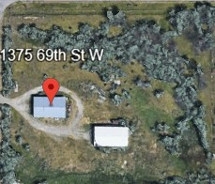
1375 69TH Street West

(At the intersection of Grand Avenue and 69th St West)

Two cold storage warehouses with electricity
- Front shop is 2,560 SF, back shop is 2,800 SF
- Both shops and 3.66 acres lease for $3,950/month + electric
- Available for Immediate Occupancy and in the County
- Call for Private Showing

Contact Rob Veltkamp

Rob Veltkamp Brokerage
406-656-2201 or 406-855-9089

